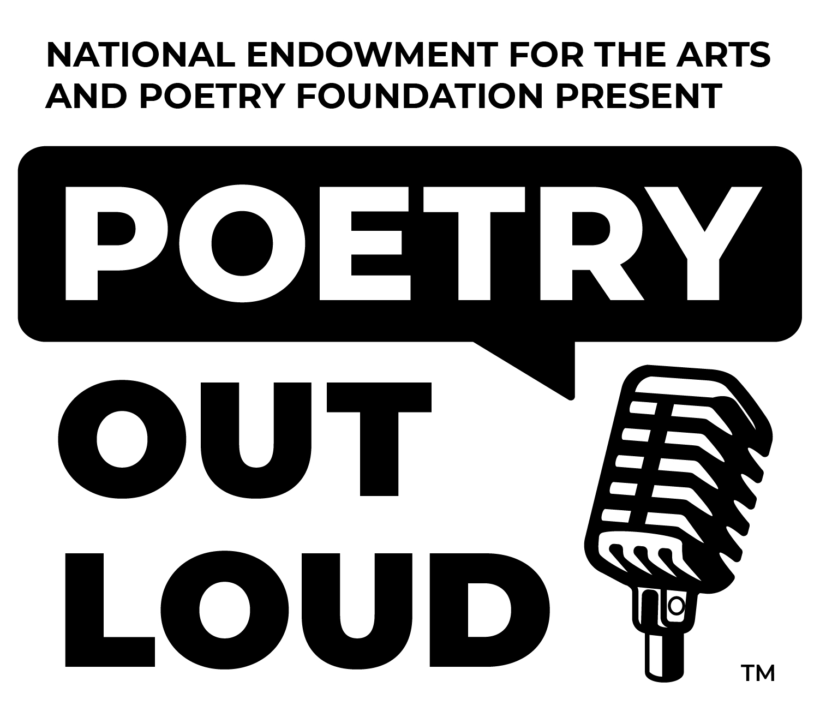

This Special Award is Presented to

For Preserving and Teaching the Art of Memorization
and Recitation of Poetry Through the
National Poetry Out Loud Competition

