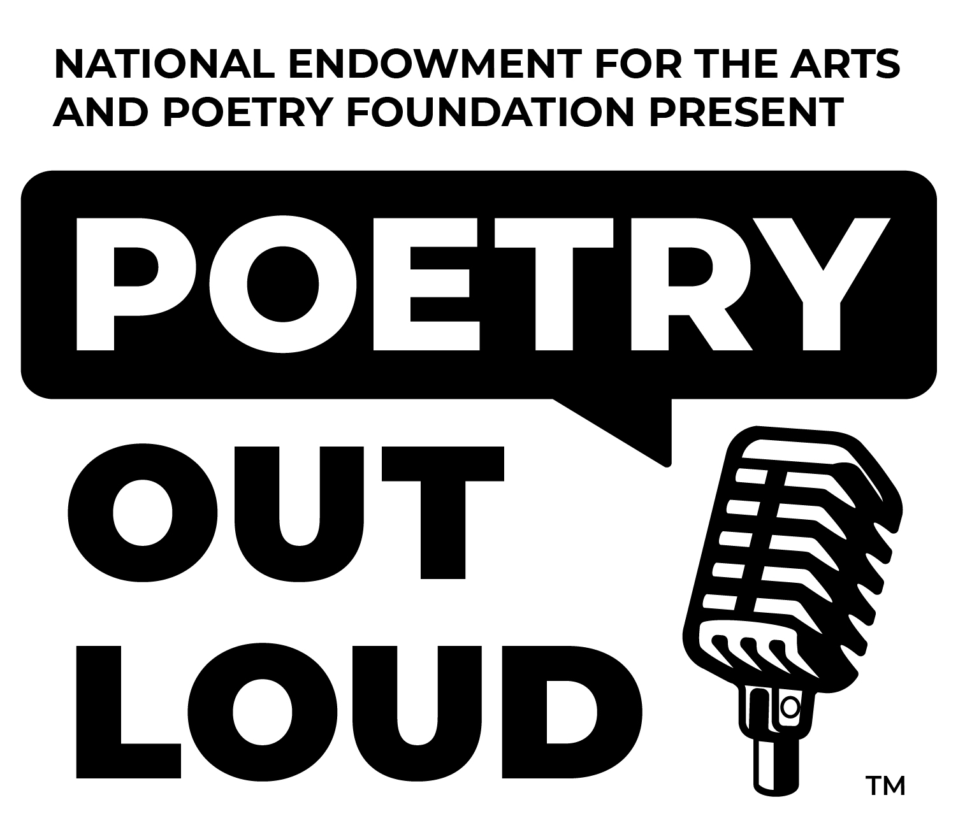

This Special Award is Presented to

For Distinguished Achievement in the Memorization and Recitation of Poetry and for Successfully Participating in the
National Poetry Out Loud Student Competition

